**A community forum to provide covid 19 support**

**1.0 Introduction**

Covid 19 has left no body in its destructive path the same again especially impacting on the way we socialize with one another. The way we used to interact whether for social or economic purposes has changed and it’s for the good of keeping us safe from covid-19. However as we seem to be fighting one disease other concerns have crept up due to our laser focused attention on covid 19, which has left the average citizen vulnerable to various threats to their well being. The scope for my study is going to be on my community for which I will develop a community forum to provide covid 19 support by availing a platform where community members can reach out to each other to ask for assistance during this difficult period of time.

**1.1 Background**

The outbreak of covid 19 has had an unprecedented global impact, with almost no country left untouched. While covid 19 is a health pandemic, the impact on the economy and society’s well being. This is in part because of efforts to limit and contain the spread of covid 19 has led to a slowdown in economic activity and people’s ability to make ends meet. For example, many in Uganda who rely on daily wages are unable to go out and work and many business owners have seen supply chains disrupted and demand dry up.

As a result of the stringent measures on movement of people, those living in the urban centers are at a high risk of starving due to the fact that they depend on daily wages which have been difficult to earn during the pandemic. According to (Godfrey Olukya et al., 2021), Thousands of Ugandans are facing food shortage in cities and towns due to restrictions announced by President Yoweri Kaguta Museveni on June 6. He banned movement from one district to another, as well as movement to city and town centers, leaving all those in suburbs stranded. Nearly 90% of the city and town dwellers in Uganda live in suburbs and slums

Starvation isn’t the only worry people may have to face as accessing medical services has also been negatively impacted by the lockdown measures in place. For example, According to (uganda.unfpa.org) In the 55 districts that are supported by UNFPA, maternal deaths increased by 41.1% in the period January-June 2020 compared to the same period January-June 2019. With the national lockdown entering into force in April 2020, most maternal deaths increments were registered across the first six months of 2020, which coincides with the onset of the COVID-19 crisis

People have come up with various solutions to the problems brought on by covid 19 like: the government and individuals providing food to neighborhoods, the government providing cash reliefs to people and so much more. But within my ability all I can offer is to develop a community forum where community members can interact for the purpose of providing those in need assistance during this covid 19 period.

**1.2 Problem Statement**

Restricting movements has had social and economic effects on people therefore now is the time never before where the advantages of virtual platforms should be leveraged for the purpose alleviating these effects brought about by covid-19.

**1.3 Main Objective**

To develop a community forum to provide covid-19 support for community members.

**1.4 Objectives**

* Collect data requirements from house hold members and few neighbors in the community due to covid-19 restrictions.
* To make designs of the proposed system based on the requirements collected
* To implement the proposed system based on the designs
* Test the system to assess performance
* Deploy the system

**1.5 Scope**

The community members around kisaasi a city suburb in Kampala are the population of interest

**1.6 Significance**

**1.6.1 Individuals**

They will have at their disposal a good platform where they can solicit for covid 19 support among community members which can help build relationships among community members .

**1.6.2 Community**

By encouraging virtual interaction among community members while limiting physical ones, the spread of covid 19 among people is greatly decreased hence keeping the community healthy and safe. On top of that it promises to be a good medium for disseminating crucial information to the community members.

**2.0 LITERATURE REVIEW**

**2.1 Introduction**

This section presents a critical analysis of community forums plus an evaluation of existing solutions that are in existence to facilitate community members interact over virtual platforms.

According to (TaskUs), a community forum is an online "meeting place" that is used to engage with others to debate share knowledge and communicate with others about a wide range of topics participants are interested in discussing.

These meeting places are increasingly taking place virtually with the increase in the adoption of smart phones and suitable data plans provided by telecom companies in the country. These meeting places are what people call social media. Therefore in this research (MAYA DOLLARHIDE, et al., 2021), Social media is a computer-based technology that facilitates the sharing of ideas, thoughts, and information through the building of virtual networks and communities

Ugandans have a preference for many social media platforms among them being Twitter, Instagram, WhatsApp, Facebook etc and according to (startcounter, 2021), Twitter and Facebook have been the two most popular social media platforms in Uganda over the past one year. Therefore, these two will be systems we shall review. Not forgetting WhatsApp which is seldom absent on a Smartphone

These three social media platforms are going to be the basis for literature review in the subsequent sections.

**2.2 Related Systems**

|  |  |  |
| --- | --- | --- |
| **Type/name of system** | **Strengths** | **Weaknesses** |
| **Facebook**. It’s is a social networking website where users can post comments, share photographs, and post links to news or other interesting content on the web, chat live, and watch short-form video(Daniel Nation, et al.,2020). Facebook has a added feature called **Facebook groups** which according to (Christina Nixon, et al., 2020), Facebook Groups*are* becoming more and more popular for people with same interests and this is mainlybecause they are a new form of community where people can *‘*connect, share and even collaborate on a given topic or idea*‘* | According to (Christina Nixon, et al., 2020), strengths of Facebook groups include;   * Members can directly add friends to the group * Groups can be about many sensitive topics because of the Privacy Option * As a group admin you can set up a list of questions for the members to answer in order to join, if you want to be more selective with your audience.   In addition to these above;   * Verifies users even further by adding a check besides the username | According to (Christina Nixon, et al., 2020), weaknesses of Facebook groups include;   * They require someone to be active in checking membership requests, content and comment frequently * Once the group is reported and taken down by Facebook all its content disappears.   In addition to the above;   * The Government of Uganda currently has Facebook blocked |
| Lessons from **Facebook** that can be applied in this study:   * I will enable the system Administrators to easily monitor content shared on the platform * Enable users to be further verified and indicate that they are definitely the person they claim to be | | |
| **WhatsApp**. Launched in 2009, WhatsApp is one of the most popular text and voice messaging apps. It’s free to use, and you can send messages, make voice calls, and host video chats on both desktop and mobile devices.(Jackie Dove and Paula Beaton, et al., 2021 ) | According to (Riyaz, et al., 2020) these include;   * It shows that your message sent or not and the receiver has received or read the message. * Send to anyone Document files up to **100Mb** such as PDF, Slideshows, etc. * App interface of WhatsApp is very simple and user-friendly, that’s why it is very easy to use. | According to (Riyaz, et al., 2020) these include;   * You need to share your number in case you want to add someone and communicate. * It can be not very pleasant sometimes due to constant messages.   In addition to the above;   * Prone to devastating fake news. * Medium for sharing malicious links |
| Lessons from **WhatsApp** that can be applied in this study:   * Enable users to determine whether their messages were read or not. * Include a user friendly and attractive user interface | | |
| **Twitter.** According to (Paul Gil, et al., 2021), it’s an online news and social networking site where people communicate in short messages called tweets. Tweeting is posting short messages for anyone who follows you on Twitter, with the hope that your words are useful and interesting to someone in your audience. Another description of Twitter and tweeting might be microblogging. | According to (Shea Laverty), these include;   * Massive Audience Potential * Widely Accessible * Customer Service and Advertisements   In addition to the above;   * Users can resend peoples posts which can expose them to more sets of eyes | According to (Shea Laverty), these include;   * Balancing Post Frequency * Limited Message Size   In addition to the above;   * Widely prone to fake news * Users content can easily not be responded to due not having a big social reach |
| Lessons from **Twitter** that can be applied in this study:   * Enable a feature where a user can repost another users post so it can be seen by more users. * Flag posts as being fake news as soon as possible. | | |

**3.0 Methodology**

**3.1 Introduction**

This chapter consists of data collection methods, techniques, and tools which shall be used to realize the proposed community based systems objectives. There are various methods that could be utilized for developing the system and they include data collection, design methods, implementation, and testing methods.

|  |  |
| --- | --- |
| **Specific Objectives of the study** | **Tools and techniques to use to achieve objective** |
| 1. Collect data requirements from house hold members and neighbors in the community | - **Interviews**. An interview is a conversation, usually between two people. But it’s a conversation where one person – interviewer – is seeking responses for a particular purpose from the other person: the interviewee according to (Bill Gillham, 2000, p.1)  -**Surveys.** According to (Fritz Scheruen, 2004, p.9), Today the word “survey” is used most often to describe a method of gathering information from a sample of individuals. |
| 1. To make designs of the proposed system based on the requirements collected | - **Process modeling.** Process modeling is the graphical representation of business processes or workflows. Like a flow chart, individual steps of the process are drawn out so there is an end-to-end overview of the tasks in the process within the context of the business environment. (Claire Vanner, et al., 2020)  - **Data modeling.** Data modeling is viewed as a way of perceiving, organizing and describing data. (H. K. Klein, R. A. Hirschheim, et al.,1987) |
| 1. To implement the proposed system based on the designs | * Use of HTML which is markup language for creating web pages, Laravel framework which supports PHP for designing the server,   MySQL for designing the database, JavaScript for an interactive interface and CSS for styling the web pages |
| 1. Test the system to assess performance | **According to (Navdeep Singh Gill, et al., 2018):**   * **Functionality Testing.** Also known as functional completeness testing. To ensure that the functionality of the product working as per the requirements defined, within the capabilities of the system. * **Usability Testing -** To make sure the user's ease to use the application, flexibility in handling controls and the ability of the system to meet its objectives. |
| 1. Deploy the system | * Deploy system on heroku which is a site that provides free site hosting |

|  |  |
| --- | --- |
| **Methodology Items** | **Description** |
| 1. Interviews | * I shall subject my parents to interviews since they are the senior members in the household. |
| 1. Surveys | * Distribute survey questions on WhatsApp to people of interest in the community |
| 1. System designs | * Utilize some software to draw designs based on the user requirements gathered. |
| 1. Implement the design | * This will achieved with the help of the following:   According to (Jennifer Niederst Robbins, 2012, p.12-13),   * **HTML**. This is the language used to create web pages. * **CSS**. WhileHTMLis used to describe the content in a web page, it is Cascading Sheet Styles (CSS) that describe how the content should look. * **JavaScript**. It’s a scripting language that is used to add interactivity and behaviors to web pages. * **XAMPP**. It’s one of if not the most popular PHP development framework. According to (apachefriends.org), it’s a completely free, easy to install Apache distribution containing MariaDB and PHP. Both of which we are going to use in the project. * **Laravel**. This is a framework built in PHP for providing Rapid Application Development (RAD) capabilities and according to (laravel.com), it’s a web application framework with expressive, elegant syntax. * **MariaDB**. It’s just like MySQL since they both use SQL to query the database and according to (mariadb.org), it’s one of the most popular open source relational databases. It’s made by the original developers of MySQL and guaranteed to stay open source. |
| 1. Deploy usability tests | - **Usability** **testing** is going to be conducted by giving the product to the potential users for a test drive in order to get feedback about the system.  - **Functionality testing** will be assessed by running through a checklist containing what the system ought to do and respond when a certain event is trigged. |

**3.2 Project Implementation Stage**

**3.2.1 Results of collecting data requirements from household members and members in the community**

**Limitations**

- Collecting neighbors’ mobile numbers to contact on WhatsApp for answering survey questions

**Results**

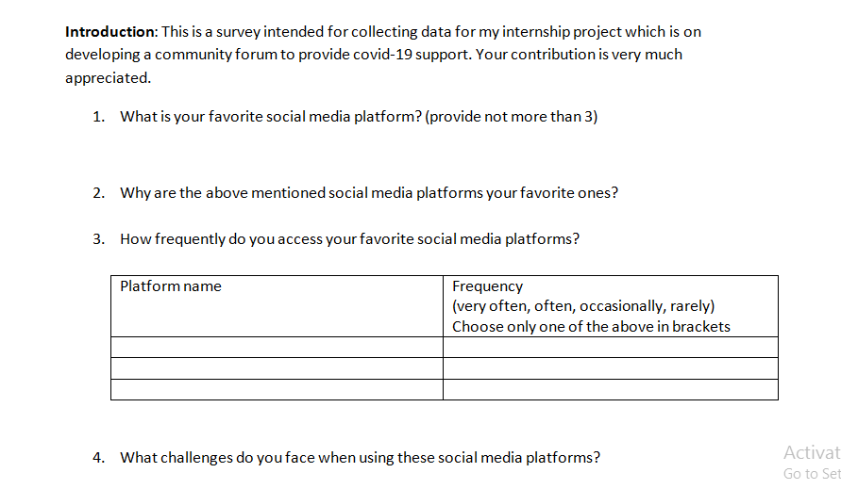

Above is an extract of the survey that was used to collect data from community members.

- From it I was able to establish many things necessary for coming up with system models

**3.2.2 Results of making system designs**

**Limitations**

- Analyzing the collected data in order to come up with appropriate system models.

- Having to make the designs online with Google drawings in the midst of the poor network and hefty data costs.

**Results**

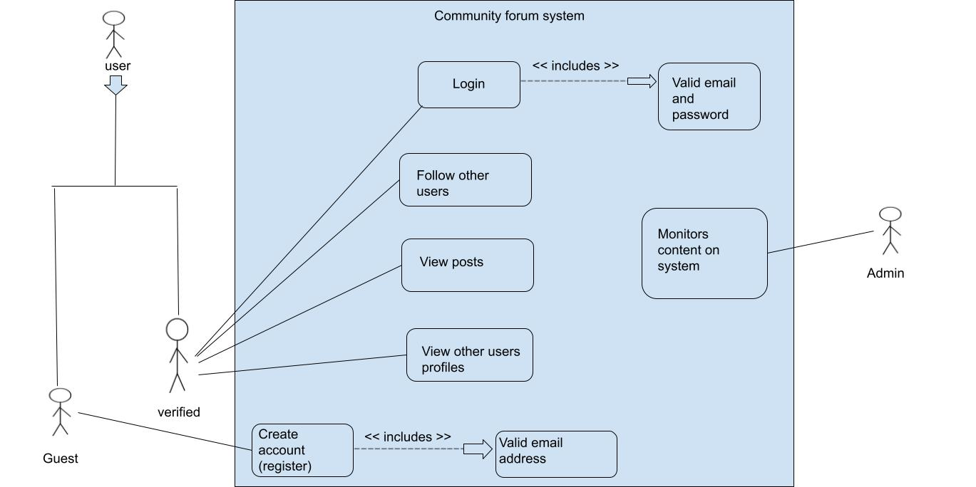

The figure above is a use case diagram responsible for showing how users shall interact with the system.

- There are two users namely guest and verified.

- The guest user has to register with the system in order to be a verified user on it.

- For the guest user to successfully register a valid and unique email address from the ones already in the database must be used.

- Once the user is verified they can use view, like, repost and reply other users’ posts.

- The admin is there to oversee what happens on the system.

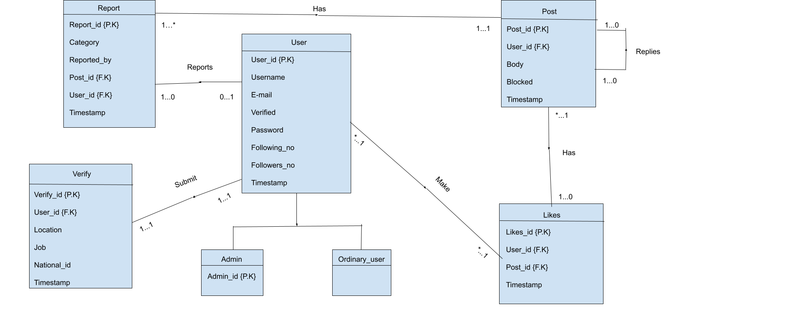

The figure above is an Enhanced Entity Relationship Diagram which is a structural diagram used for database design

- There are 5 entities namely user, post, likes, verify and report.

- There are two types of users of the system namely admins and ordinary users

- Users can follow each other and posts can be replied to.

- A user may or may not send a post while a unique post can only be sent by one user

- A user can make many likes while a particular like belongs to only one user

- A post may or may not have a like while a particular like belongs to only one post

- A user may or may not report a post while a unique report can be made one user

- A post can be replied to by a user.

- A user may or may not seek to verify their account while a unique verification form has one user

**3.2.3 Results of implementing the system based on system designs**

**Limitations**

- Finding a suitable template for designing the user interface.

**Results**

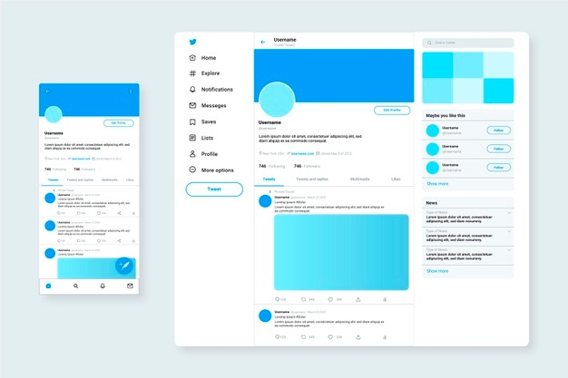

This is an image of the twitter template which inspired the user interface design of the system

**3.2.4 Results of testing the system**

**Limitations**

- In the midst of covid-19 Standard Operating Procedures (SOP’s) going around with my laptop for users to try out the system proved to be difficult.

- The alternative to this would be to install some software in order to be able to run the system however few of them had personal computers and the ones who did were reluctant to installing these required software

**Results**

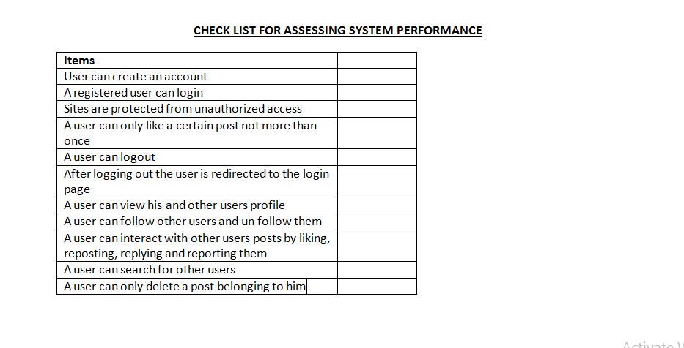

This is a checklist with system functionalities each of which was to be either checked if the system functionality worked or left blank when a certain system functionality was faulty.

**3.3 Functional and non-functional requirements**

|  |  |
| --- | --- |
| **Functional** | **Non-functional** |
| * Check new users email address to see if it’s a valid one. * Also checks the new users email address to see if it’s a unique one by cross checking with the database * Checks login credentials for validity in the database * Display posts made by a user on that users profile page * Users can delete posts only which were created by them * Users can report a post by clicking the area around the 3 dots situated at the top right hand corner of a post * System will send notifications to your email address in order to keep up to date with what is taking place on the system for example, (someone liking your post, someone sending you a message ) | * Shouldn’t allow users to delete posts that don’t belong to them * A new email address should always be unique hence users shouldn’t have the same email address * A logged out user is always redirected to the login page * Users who don’t belong to a particular group shouldn’t be able to view messages in it * A user shouldn’t be able to like a post more than once |

**3.4**

|  |  |
| --- | --- |
| **Challenges in problem domain** | **Functional requirements to address the challenge** |
| * Users are often mislead by false information and burdened with spam messages | * These posts can always be reported by clicking around the 3 dots at the top right hand corner of these posts and appropriate action shall be taken |
| * Users with a low popularity on platforms very often aren’t able to reach other users | * The system will suggest for such users people to follow so that they can broaden their reach and receive more attention on their messages * There’s a button called “repost” on the posts which can be used to post what somebody has posted hence spreading their message |
| * Users may only want to visit the platform upon receiving some notifications about what is taking place | * Send notifications via email of anything new occurring on the platform |

**References**

* 1. Godfrey Olukya. (2021, July, 7). Stranded Ugandans from locked down cities 'starving’. https://www.aa.com.tr/en/africa/stranded-ugandans-in-locked-down-cities-starving/2297310
  2. Uganda.unfpa.org. (2021, May, 4). Promising results in reducing maternal

deaths.<https://uganda.unfpa.org/en/news/%C2%A0promising-results-reducing-maternal-deaths>

* 1. TaskUs. Community forum.

<https://www.taskus.com/about/glossary/community-forum/>

* 1. MAYA DOLLARHIDE. (2021, May, 15).

Social Media. <https://www.investopedia.com/terms/s/social-media.asp>

* 1. Startcounter. (2021). Social media stats in Uganda. <https://gs.statcounter.com/social-media-stats/all/uganda>
  2. Christina Nixon. (2020, October, 20). Facebook Groups: Advantages and Disadvantages. <https://iconicmagazineonline.com/2020/04/21/facebook-groups-advantages-and-disadvantages/>
  3. Jackie Dove & Paula Beaton. (2021, March, 21). What is WhatsApp?<https://www.digitaltrends.com/mobile/what-is-whatsapp/>
  4. Riyaz. (2020, October, 2). Top 27 WhatsApp Advantages and disadvantages in our life (Updated). <http://www.extracatchy.net/advantages-and-disadvantages-of-whatsapp/>
  5. Paul Gil. (2021, June, 25). What is Twitter and how does it work? <https://www.lifewire.com/what-exactly-is-twitter-2483331>
  6. Shea Laverty. Advantages and Disadvantages of Twitter. <https://www.techwalla.com/articles/advantages-disadvantages-of-twitter>
  7. Interview: Definition, Types of interview. <https://www.iedunote.com/interview>
  8. Bill Gillham. (2000). Research Interview
  9. Fritz Scheruen. (2004). What is a survey
  10. H. K. Klein, R. A. Hirschheim. (1987, January, 1). A Comparative Framework Of Data Modeling Paradigms And Approaches. <https://doi.org/10.1093/comjnl/30.1.8>
  11. Claire Vanner. (2020, December, 15). What is Process Modeling? 6 Essential Questions Answered. <https://www.bizagi.com/en/blog/process-modeling-and-mapping/what-is-process-modeling-6-essential-questions-answered>
  12. Navdeep Singh Gill. (2018, December, 17). System Testing Types, Best Practices and Tools Overview. <https://www.xenonstack.com/insights/what-is-system-testing>
  13. Jennifer Niederst Robbins.(2012). Learning Web Design: A Beginner's Guide to HTML, CSS, JavaScript, and Web Graphics.
  14. The PHP Framework For Web Artisans. <https://laravel.com/>
  15. What is XAMPP? <https://www.apachefriends.org/index.html>
  16. New to MariaDB server? <https://mariadb.org/>